SciBrilliance Website Report
This website consists of six pages mainly:
- Home Page
- Courses
- Resources
- About
- Forum
- Feedback
The purpose of this website is to help students understand basic science topics and to help students grow and flourish.
Goals of the Website
- Support learning for students: the courses page helps students understand science, covering Physics, Chemistry and Biology.
- Better understanding of subjects: Clear specifications and explanations and structured content that help make tricky topics easier to grasp.
- Student forum page: students get to interact with one another and get to share their views on different topics.
- Downloadable materials: Students get to download materials and study at their own time.
b) Target Audience
The target audience includes:
- Age group: 16-21 years old.
- Gender: All genders.
- Location: Students locally and possibly international uses.
- Education level: Secondary school students
Technical aptitude
- Comfortable using everyday devices like smartphones, tablets or computers.
- Equipped with the basic to moderate digital know-ho\w needed to learn, explore and interact online.
c) Type of Website
The website is an educational (e-learning) website.
The content will include:
- Study notes for different subjects
- Study tips
- Downloadable resources such as notes
- A forum page, where students get to interact with one another
- A feedback section for user interaction
Information Design and Taxonomy
The website is designed into categories that users can easily navigate from one page to another to access learning materials. The structure is simple and user-friendly, allowing students to navigate easily without confusion.
Website Structure
The website consists of the following main sections:
- Home
- Courses
- About
- Resources
- Forum
- Feedback
Site Map (Navigation Structure)
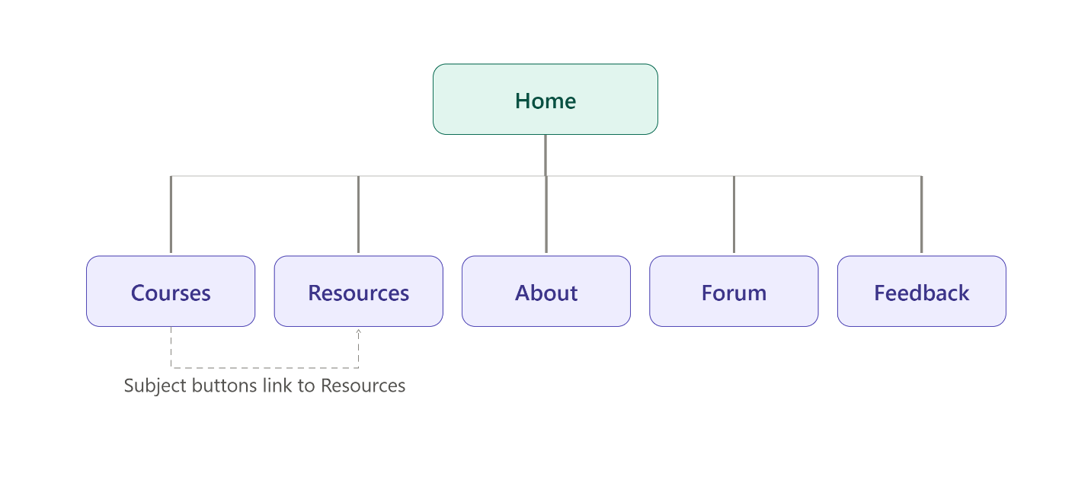
Navigation Paths
- Users start at the Home Page
- From Home, they can navigate to any section using the menu bar
- Within courses users can select a subject and move to the Resources
- At the Resources, students access notes and they can download them
- From the Resources, users can move to the about page and get to know more about the site.
- Users can visit the forum to ask questions or share ideas with others.
- Users can provide comments on the quality of the website, report issues and suggest improvements using the feedback form.

Story Board flow chart
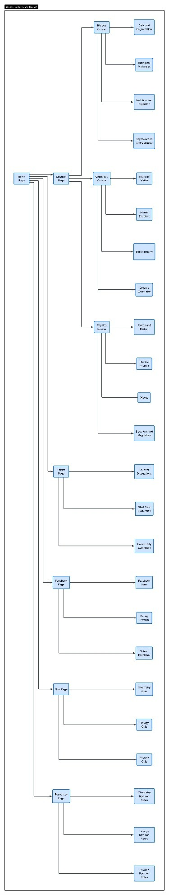

Page Template Design
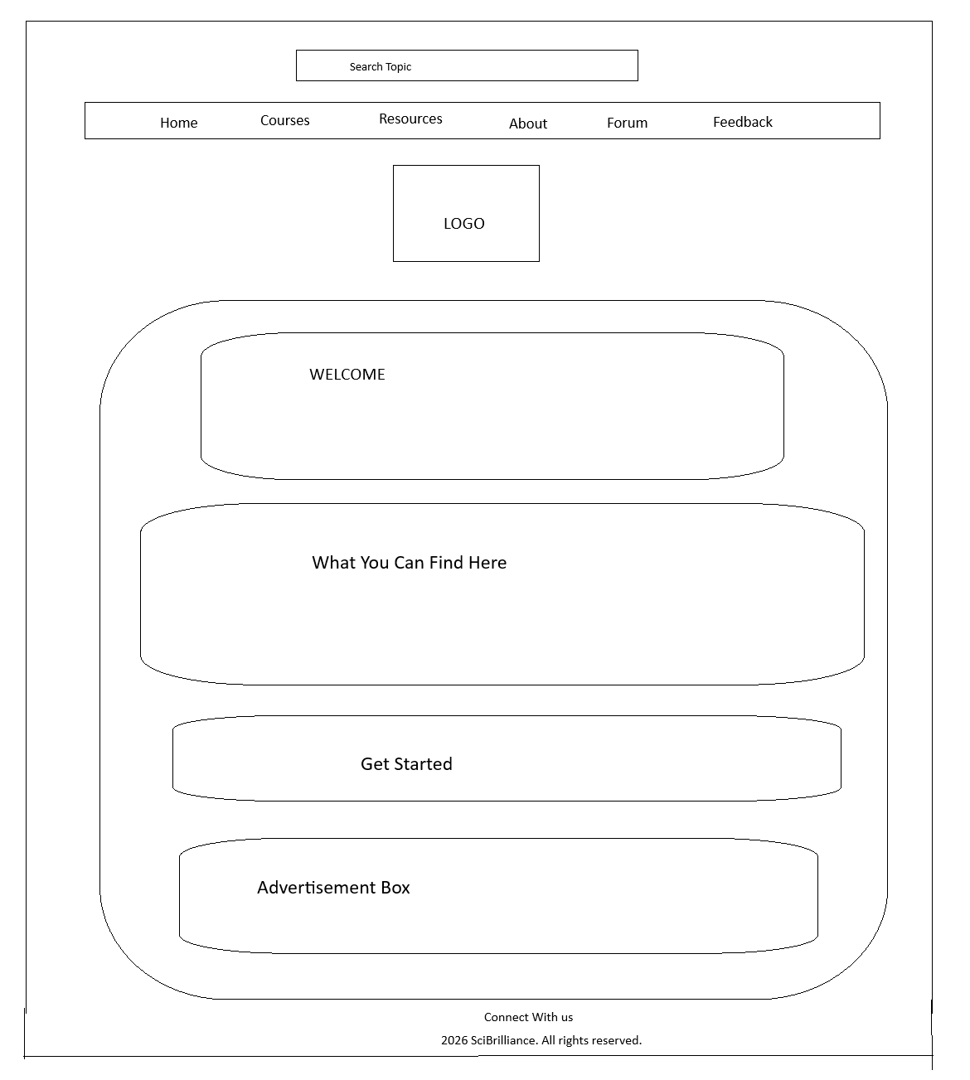

Technical Brief
This website was developed using tools that are of its level
Technologies Used:
- HTML-used to structure the web pages.
- CSS- used to style and design the layout.
- JavaScript- used to add interactivity (forum posts)
Software Tools
- Visual Studio Code (VS code)-for writing and editing code
- Web Browsers- for testing the site
- GitHub-for version control and hosting the website.
Graphics Tools
- GIMP-for designing images, banners and logos
- Free online images-for visual enhancement
GitHub Commands Used
- git init
- git add .
- git commit -m "Initial commit for SciBrilliance e-learning website"
- git branch -M main
- git remote add origin https://github.com/USERNAME/REPOSITORY-NAME.git
- git push -u origin main
After pushing the files to GitHub, GitHub pages was enabled using these steps:
- Open the GitHub repository
- Go to settings
- Select pages
- Under Branch, choose main.
- Select the root folder /.
- Click Save.
- GitHub generates a public website link.
Website Link address: https://lebole-cse.github.io/cse25-421/
Quality Assurance
The website was tested on different devices and on different website being google, chrome, Mozilla Firefox, and Microsoft Edge.

Google Chrome
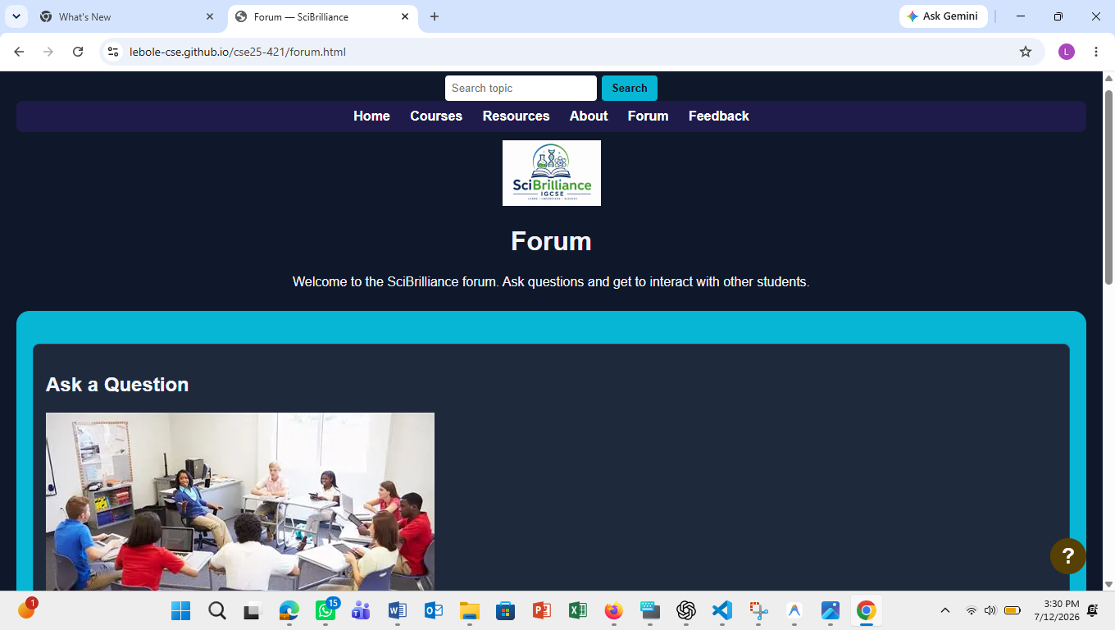

Mozilla Firefox

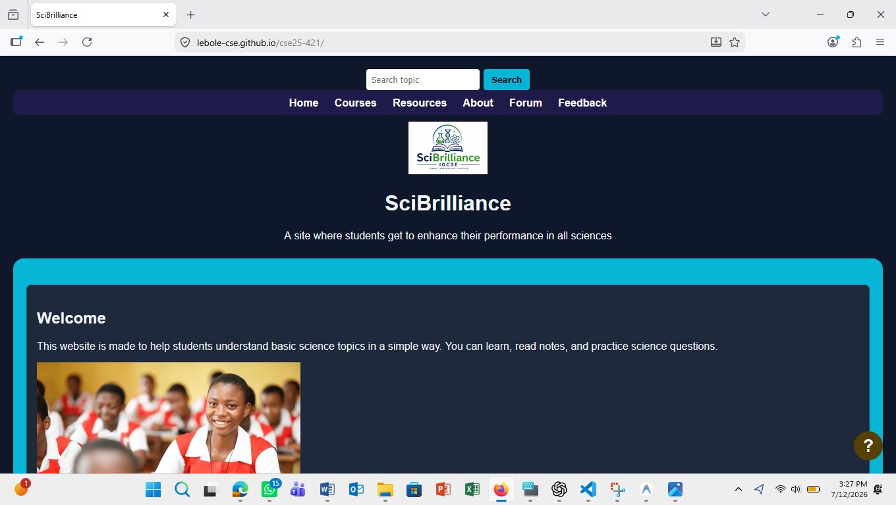
Microsoft Edge

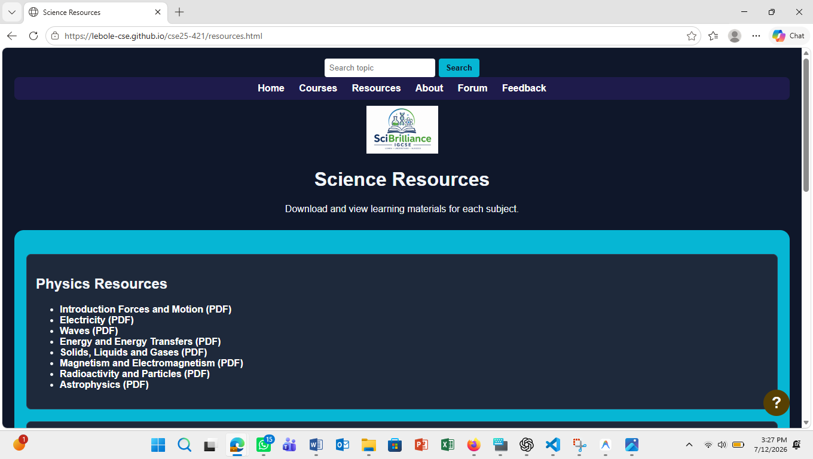

Publishing and Promotion
The website can be promoted through:
- Sharing the GitHub link with classmates and on different social media platforms.
- Posting the link in LinkedIn and WhatsApp groups or team groups.
- Sharing the link with IGCSE students and BGCSE students.
Publishing the site online will help people of different devices to access it when the have an internet connection.

WireFrames
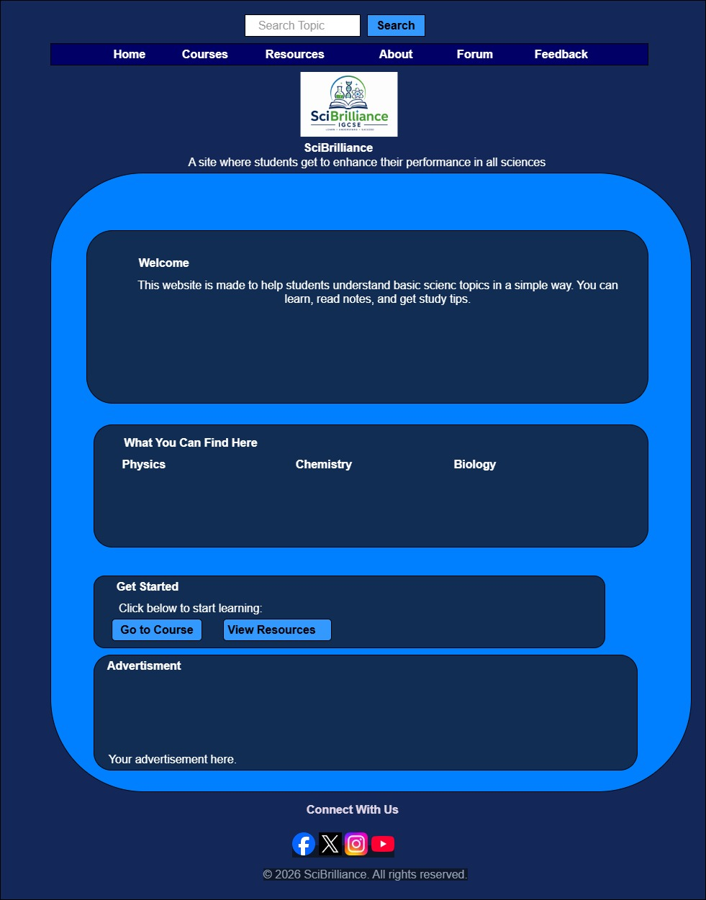

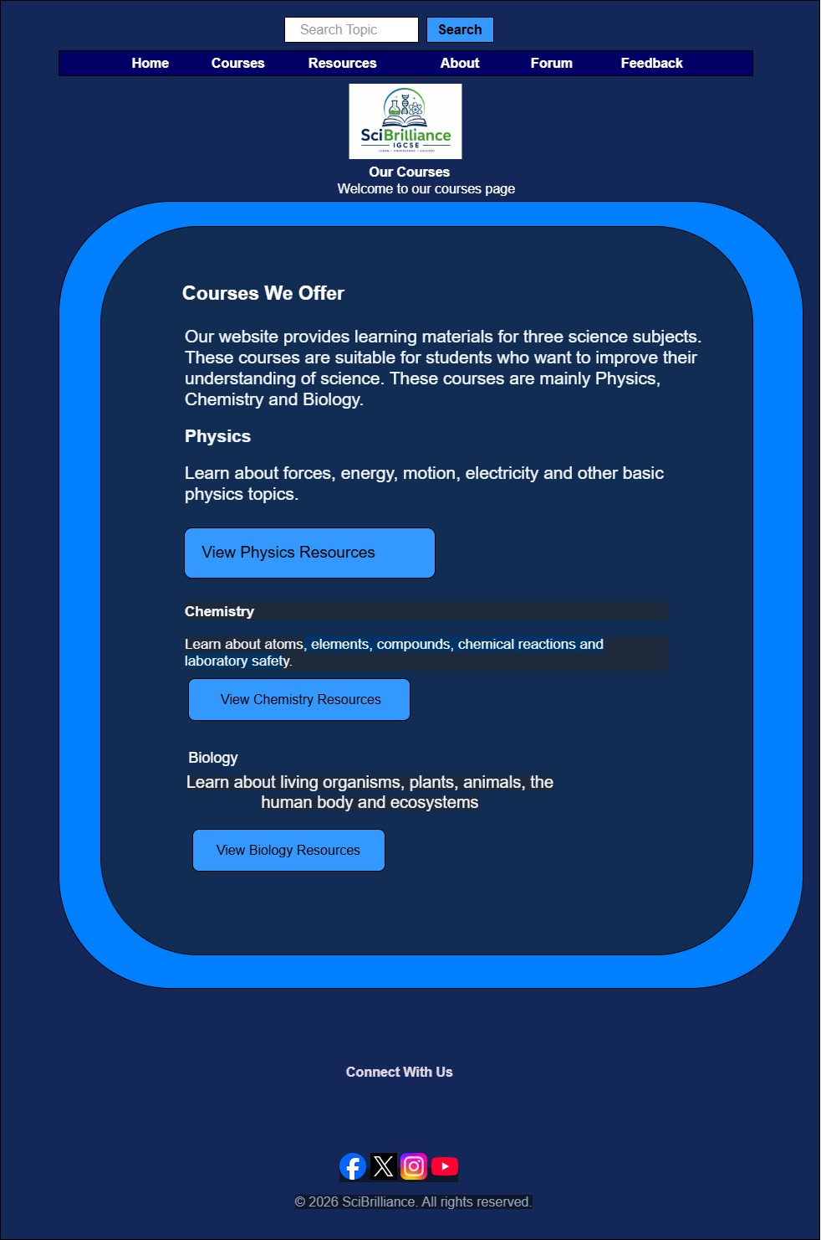
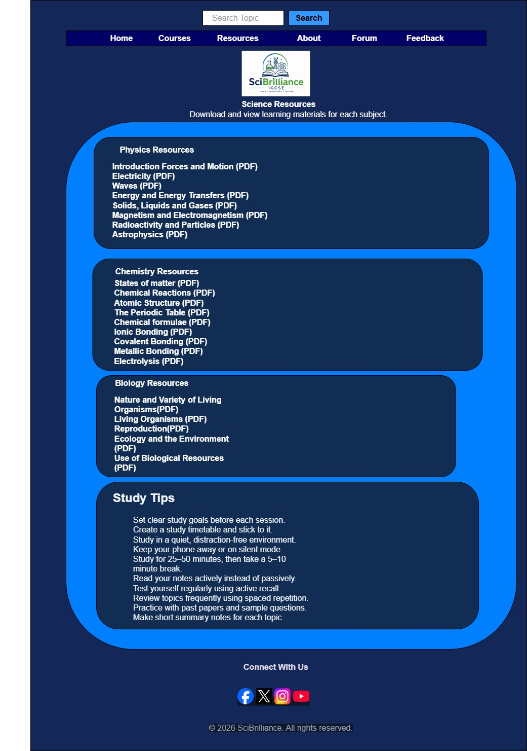

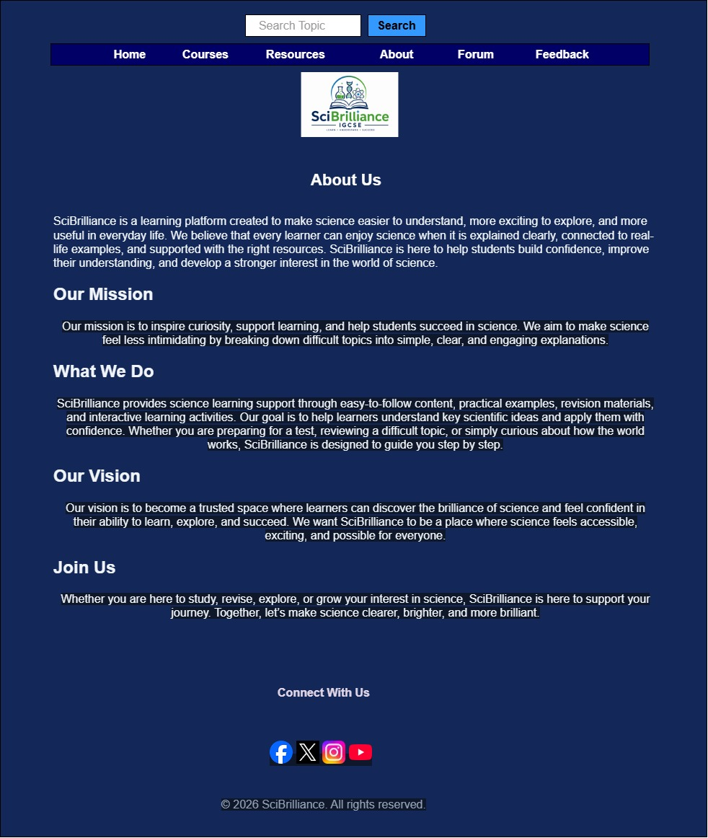

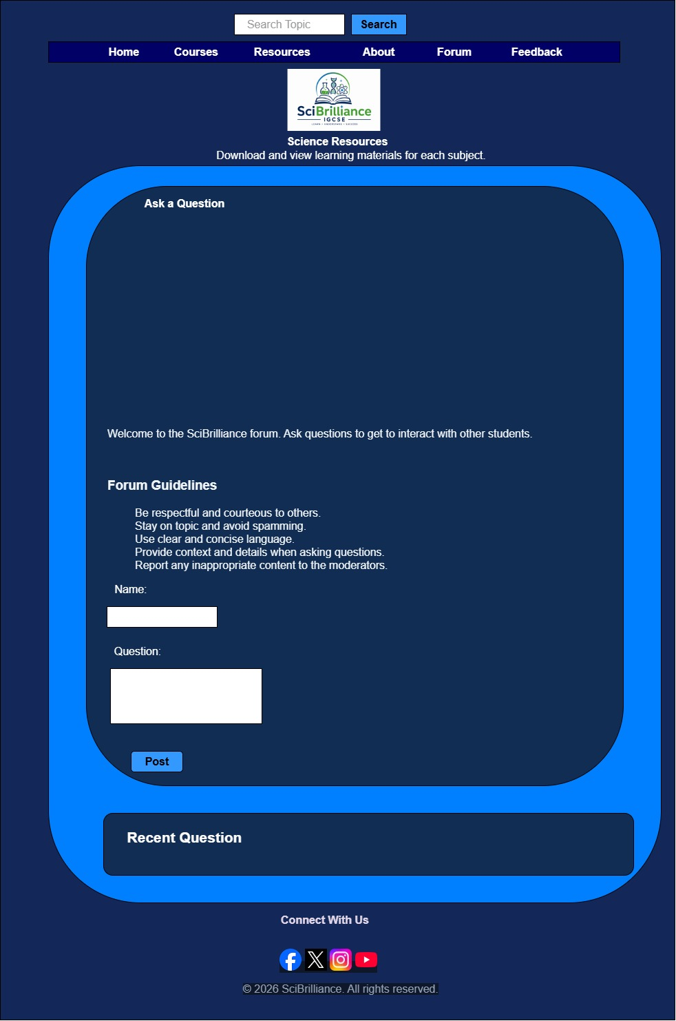
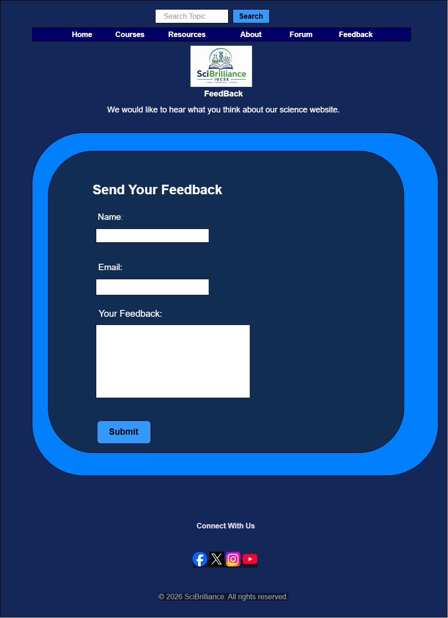
Website Design And Usability Report
Introduction
The SciBrilliance website is an IGCSE Science e-learning platform. The website was designed to support students with sciences being Chemistry, Biology and Chemistry by providing access to IGCSE notes and study tips. The site also has a forum that students can use to interact with one another and share their views on different topics so as to ask other students questions. The report touches on the purpose of the website, the structure, design , navigation, usability and accessibility and future improvements.
Purpose of the Website
The main purpose of the site is to help students improve their understanding in all sciences. This website has been created for students preparing for their IGCSE examination. The site is also open to BGCSE students as what they cover is similar to what IGCSE students cover in their school syllabus.
The website is aimed at students who need access to simple, short notes for science revision.
Website Structure
To make this website, the hierarchical structure was taken into use. this is because the homepage acts as the entry point, and users can move from it to other sections being the Courses, Resources, About, Forum and Feedback. Each section contains content like subject areas for Chemistry, Physics and Biology.
The structure was put to use as it promotes:
- Easier navigation: students get to move from one page to other pages without getting confused
- The three-click rule: it makes it easy for students to reach important pages within a few clicks from the homepage.
- Improving the learning flow: students can choose what they need, such as study tips and asking questions in the forum.
The site is made of 6 pages being:
- Home Page: the home page introduces the student to the website giving them a glimpse of what the site is about.
- Courses: this page holds information about Chemistry, Biology and Physics topics into organized units.
- Resources: provides notes and study tips.
- About: tells users as to what the site is about and who it is focused on
- Forum: students get a space where they can interact with one another and get to share their views on different topics and get to ask one another questions to get a better understanding on different topics.
- Feedback: allows users to give reviews on the usability of the website and their learning experience promoting improvements in the website.
Design and Layout
All pages of the website we built adopt a unified structure, each containing a navigation bar, header banner, main content, and footer module. We built a responsive grid system based on Bootstrap to adapt the website to desktop, tablet, and mobile phone screens, which enables users to quickly understand the website and navigate smoothly between different pages.

Desktop Image
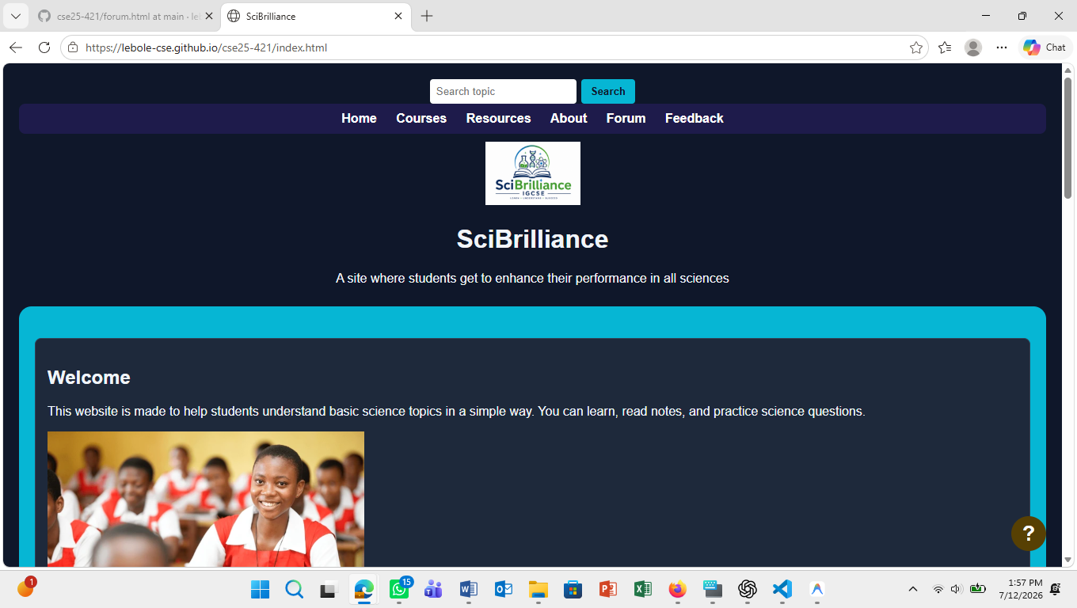

Mobile Screen
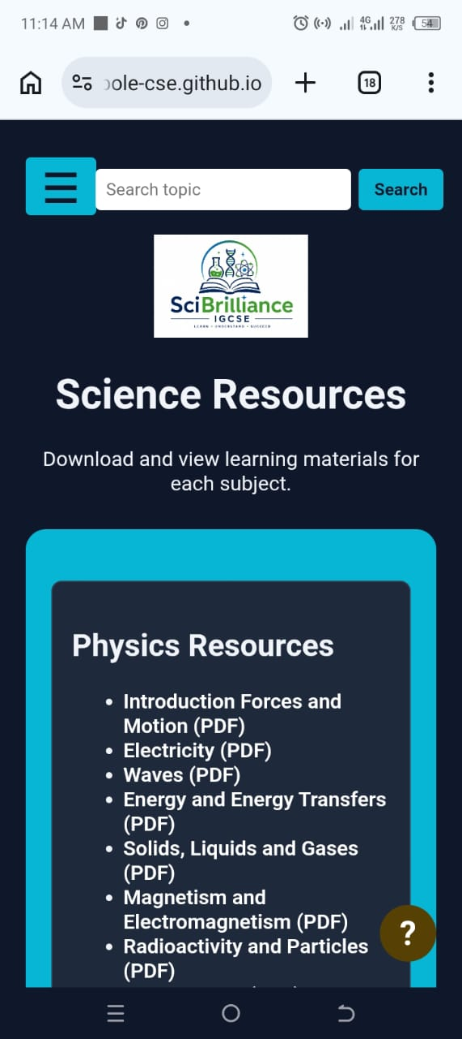
Typography
The site uses Arial as the main font. Arial is a good font for an eductionl website because it is simple and readable. The heading are large and bold than the body text, with creates a clear visual hierarchy. This makes it easier for users to identify page titles, section headings and important content. The text color works well with the dark background. Links are displayed in white, which makes them stand out from the dark background. Button use a cyan background with a black text, making them easy to identify as interactive elements.
Navigation and Three-Click Rule
The website has a simple navigation bar with links to Home, Courses, Resources, Quiz, Forum, and Feedback. This makes the main pages easy to reach from almost anywhere on the website. The navigation supports the three-click rule because most important content can be reached within three clicks. For example, a student can open the home page, click "Resources", and then click a PDF resource. A student can also reach the quiz from the navigation bar in one click.

The three-click rule is useful because it encourages simple navigation. Users should not have to click through too many pages to find important information.

Use of White Space

The site uses active white space effectively. Active white space is the intentional empty space made between elements to improve organization and readavility. The white space prevents the website from looking cluttered and allows students to focus more on important information and makes the interface easier to use.

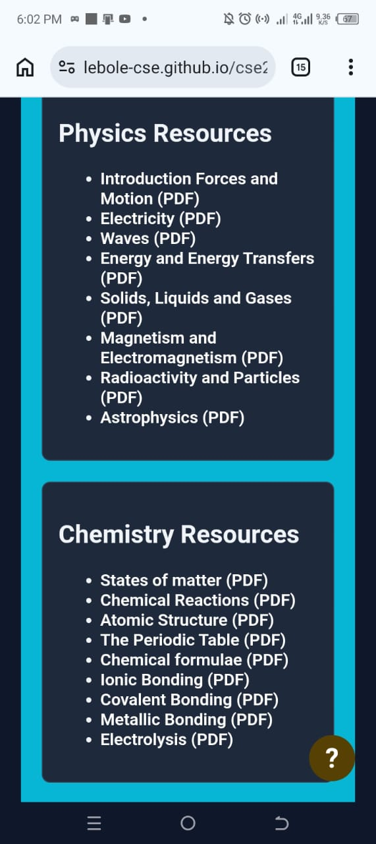
The resources page using spacing around the course cards.

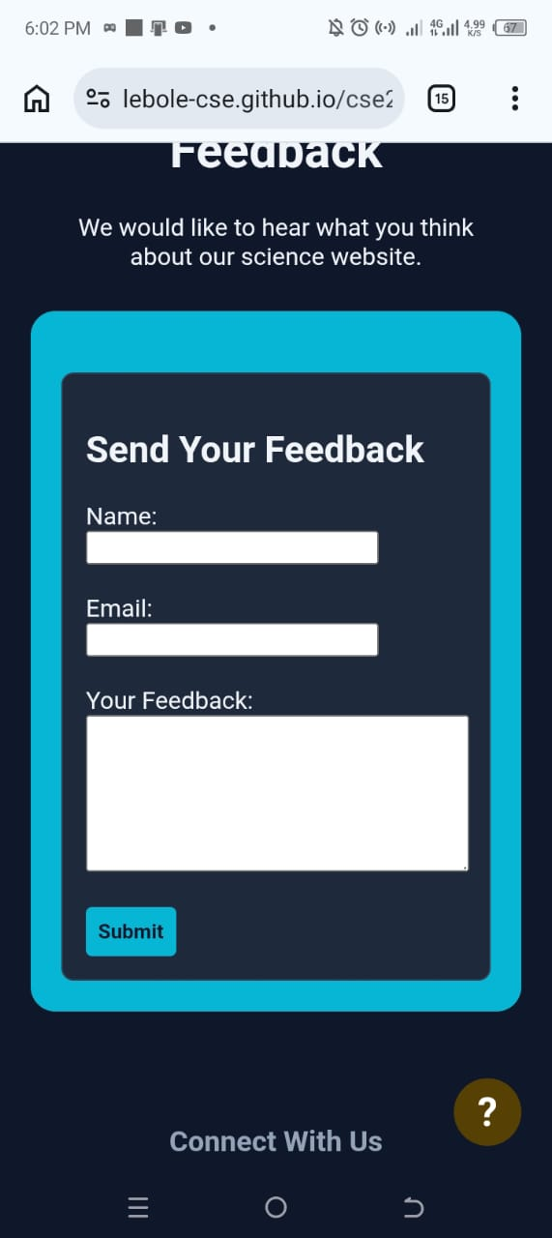
The Feedback page uses spacing in between the form fields and the submit button.
Interactivity and Functionality
The website includes several interactive features being the search button across all pages.
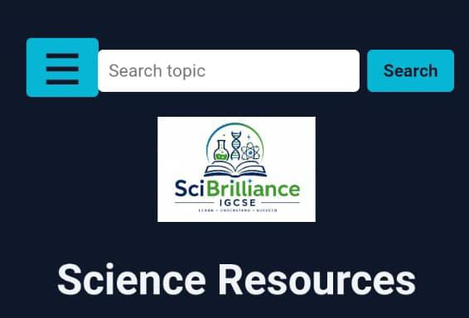

The feedback page includes a form and a submit button.
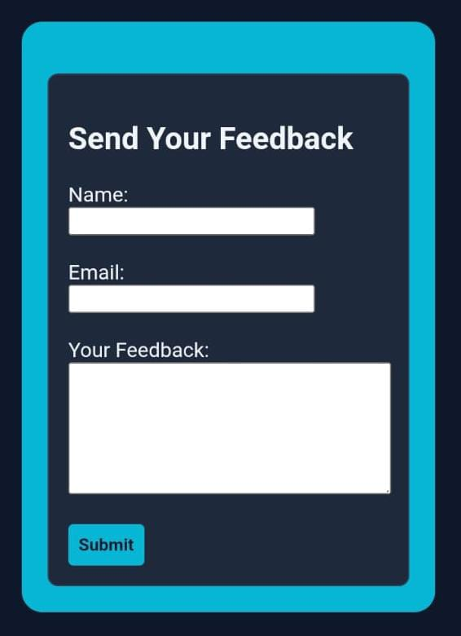

These interactive buttons and forms make the site engaging, it encourages students to interact with the learning content and track their understanding.
Functional Requirements
- Navigation- the site should provide a clear navigation menu that users use to access all pages.

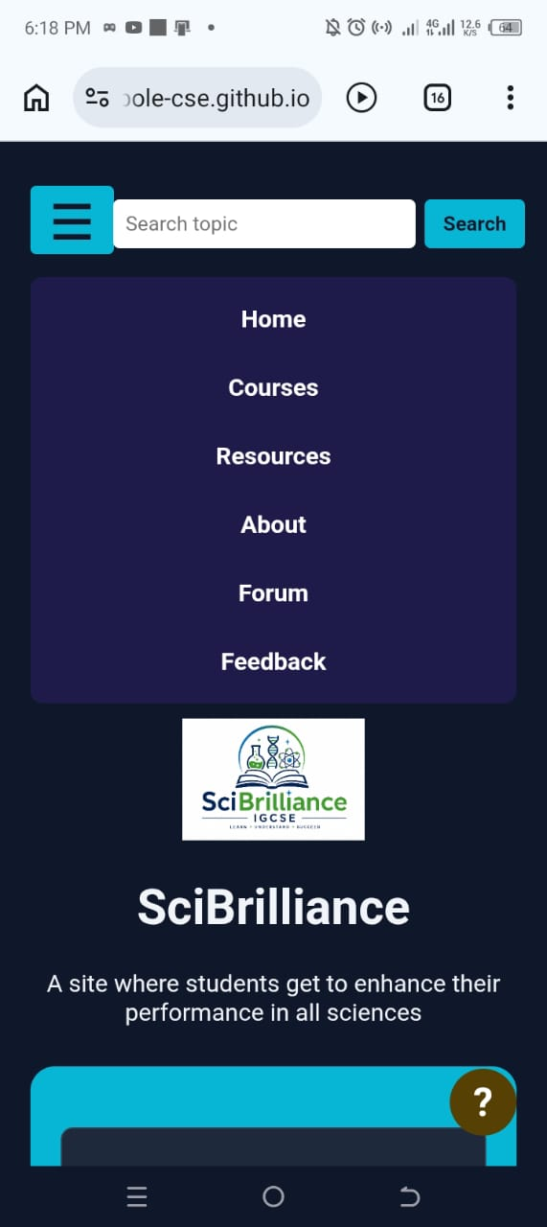
- Course access- the site allows users to view IGCSE course content organized into Chemistry, Biology and Physics
- Resources- the site allows users to access notes on different topics.
- Forum- the site allows users to interact with one another and share ideas on different topics.
- Feed functionality- the site shall allows students to submit feedback on the site by entering their names and email and lastly fill the form with their queries.
- Responsiveness- the site shall adjust its layouts for desktops, tablets and mobile devices.
- Accessibility- the site shall support visible tests and labels, keyboard navigation and visible focus states.
Accessibility
The website is designed with accessibility in mind, featuring semantic HTML elements, good contrast for readability, clear labels, and skip links on certain pages. These navigation elements make it easier for users to understand and engage with the site. Plus, with Bootstrap in the mix, the site boasts a responsive design, allowing students to access it seamlessly from any device whether it’s a laptop, tablet, or mobile phone.

Quality Assurance
The site was tested by checking its pages, navigation links, layout and interactive features. Browser testing was done on different websites such as Google Chrome, Microsoft Edge and Firefox Mozilla.
Firefox


Google Chrome


Microsoft Edge


Mobile Testing

Publishing
The website ws published on GitHub Pages. GitHub Pages was suitable because the project is a website built with HTML, CSS, JavaScript and Bootstrap. The link is:
https://lebole-cse.github.io/cse25-421/
The responsive layout ensures that content stacks neatly, and the navigation seamlessly transforms into a mobile-friendly menu. However, during testing, we ran into a hiccup related to GitHub Pages and how it handles filename case sensitivity. Some links were pointing to capitalized filenames like Feedback.html, but the actual file was named feedback.html. This mismatch led to a 404 error on GitHub Pages since it distinguishes between uppercase and lowercase filenames.
Future Developments and Recommendations
SciBrilliance is a good foundation for a science learning website, but several improvements would make it more useful and professional.
The first thing that could be done to improve the forum functionality. Instead of showing only an alert, posted questions should appear under the “Recent Questions” sections. In a more advanced version, questions can be stored in a database so that students can return later and view other students responses.
The second recommendation is to improve the feedback form. Feedback should be saved or sent to an email address so the website owner can review user comments. The form should also validate required fields.
The third recommendation is to improve the search feature. Instead of showing an alert, it should find matching topics, resources, or forum page. This would make the website more useful for students who are looking for a specific science topic.
The fourth recommendation is to clean up spelling, grammar, encoding errors, and HTML structure. This will improve the quality and professionalism of the website.
The fifth recommendation is to add more learning features, such as videos, topic summaries, revision flashcards, progress tracking, downloadable worksheets, and past paper practice. These features would make the website more interactive and valuable for students.
Conclusion
The SciBrilliance website is a useful educational website with a clear purpose helping students improve their science knowledge. It includes subject information, downloadable resources, study tips, a forum page, feedback options, social media links, and a help icon. The design is visually engaging, the layout is easy to understand, and the main pages are simple to access.

However, the website still needs improvement in areas such as navigation consistency, broken or missing resource links, form functionality, accessibility, and HTML quality. With these improvements, SciBrilliance could become a stronger, more reliable, and more user-friendly learning platform for science students.

